**Course: Advance Bio Informatics**

**Module Title: SNOMED**

**Module No: 80**

**SNOMED**

Systematized Nomenclature of Medicine -- Clinical Terms

Standardized, multilingual vocabulary of clinical terminology

Physicians, health care providers for electronic exchange of clinical health information.

National Library of Medicine.

Common language.

Quality of patient care across many different provider specialties.

Improves accuracy of patient data analysis.

Standard medical terminology across the enterprise, and within other hospitals.

Simplifies the query and resulting report.

**UMLS**

Unified Medical Language System (UMLS) is a comprehensive list of biomedical terms for developing computer systems capable of understanding the specialized vocabulary used in biomedicine and health care.

The UMLS consists of these major components:

1. Metathesaurus
2. Semantic Network
3. Specialist Lexicon

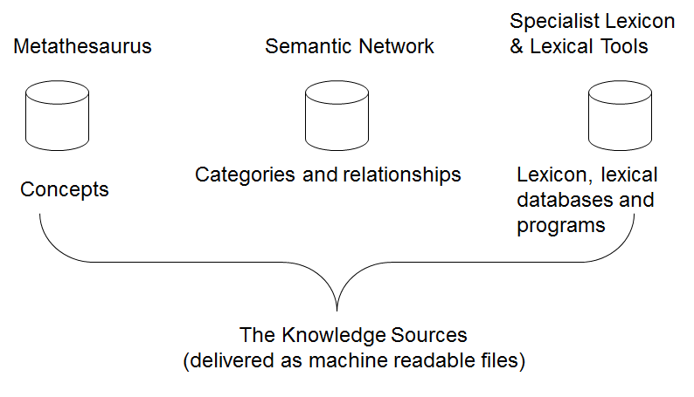

**UMLS Objective**

Knowledge Sources used to overcome:

**Disparities** in lang. format

**Ex:** atrial fibrillation, auricular fibrillation, af.

Problems in **mapping** and **aggregating** within and across databases and systems.

Disparities in granularity and perspective

**Ex:** Contusions, hematoma, bruise

**Ex:** Instruct patient to promptly report

Nosebleeds and excessive Bruising (NIC), Epistaxis (MeSH)

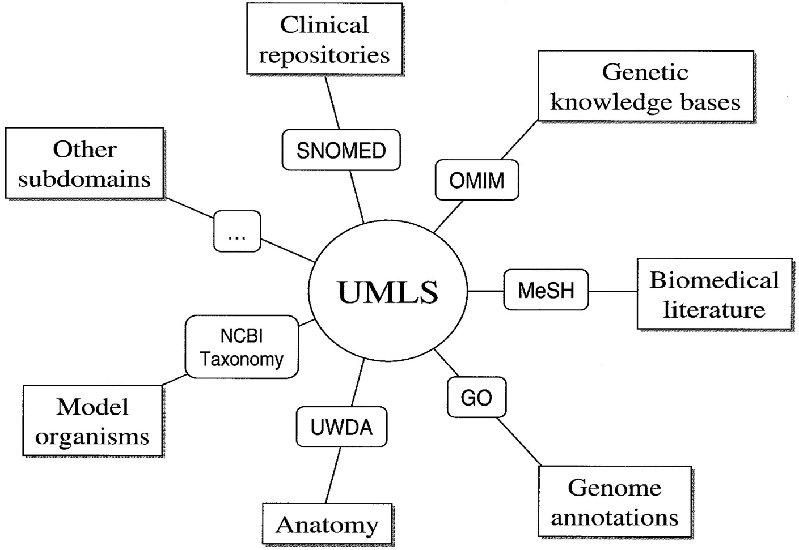

**UMLS Uses**

Information retrieval.

Thesaurus construction.

NLP.

Automated indexing.

Electronic patient records.